|  |  |
| --- | --- |
| *Pacific Gas and Electric Company* | |
| ***Release 9.8/WEBR3.0 Installation Guide*** | |
|  |  |
|  |  |
| **Project** | **ED AM/GIS** |
|  |  |
| **Prepared by** | Dale Avery |
| **Date** | 12/2/2015 |
| **Version** | **2.0** |
| **Version Type** | **Draft** |

|  |  |  |  |
| --- | --- | --- | --- |
| **Revision History** | | | |
| ***Document #*** | ***Date*** | ***Author*** | ***Summary of Changes*** |
| 1.0 | 11/12/2015 | Philip Penn | Initial Document Creation |
| 2.0 | 11/17/2015 | Dale Avery | JET QC/QC and Action Handler |
|  |  |  |  |

Table of Contents

1 Introduction 4

1.2 Purpose 4

1.3 Terms Used 4

1.4 External Documents 4

1.5 List of Fixes 5

2 EDGIS 9.8 6

2.2 Apply TFS 25584: Add UFM Indexes for Butterfly Diagram WEBR Python Script 6

2.3 Apply EDER_Data_Model_Changes.py Python Script 6

2.4 Validate Model Name Assignment 6

2.5 Assign QC/QC rule by Feature Class and Subtype 6

2.6 Assign the GDBM Action Handler 6

2.7 Run Scripts to Create Application Data: 6

2.8 25576: Hide AVAILABLE field on duct and ductdefinition 7

2.9 Update Data Model Version Table 8

3 WIP 3.0 9

3.2 Apply TFS 25662 Create JET tables in WIP 9

3.3 Apply TFS 25487 Grant Business Objects permissions to WIP 9

3.4 Update Data Model Version Table 10

4 Known Issues 11

1. **Introduction**
   1. **Purpose**

This document is intended to detail the implementation and configuration steps required to implement Release 9.8/WEBR3.0 Installation Guide. This document describes the various configuration aspects required to complete any manual or automatic patch associated with this release. Each section in this document contains the steps required to patch the system in production.

* 1. **Terms Used**

|  |  |
| --- | --- |
| OOTB | Out of the box. Unmodified from the commercial version. |
| TFS | Team Foundation Server |

* 1. **External Documents**

Referenced are any external configuration documents or exports. These are documents that contain more detailed information about configuring a system or documents that can be loaded into an application to perform the configuration detailed in this document.

1. Supporting documentation folder
   1. TFS documentation location:

$/EDAMGIS/Source_Development_10_2_1/Documentation/Data Model/Release Documentation/EDER/9.8

<http://edappgistfsprd1:8080/tfs/ElectricDistCollection/EDAMGIS/_versionControl#path=%24%2FEDAMGIS%2FSource_Development_10_2_1%2FDocumentation%2FData+Model%2FRelease+Documentation%2FEDER%2F9.8&_a=contents>

* 1. **List of Fixes**

Below is the list of change requests detailing all fixes for the data model for this release:

|  |  |
| --- | --- |
| **Item Number** | **Title** |
| [25585](http://edappgistfsprd1:8080/tfs/ElectricDistCollection/EDAMGIS/_workitems/edit/25585) | Master TFS DM 9.8 |
| [25576](http://edappgistfsprd1:8080/tfs/ElectricDistCollection/EDAMGIS/_workitems#_a=edit&id=25576) | Hide AVAILABLE field on duct and ductdefinition |

# EDGIS 9.8

## Apply TFS 25584: Add UFM Indexes for Butterfly Diagram WEBR Python Script

1. Copy the **add_ufm_indexes.py** file locally from the supporting documents folder referenced in Section 1.3.
2. Right click on the .py file and open it in IDLE editor.
3. Edit the “**Data_Connection**” in the file to use the correct password-saved SDE file. This SDE file should connect to the database as EDGIS.
4. Release all existing locks in the SDE to ensure exclusive connection. Execute the script.
5. Ensure there is no error occurred. Copy the logs into a text file and attach to the TFS ticket.
   1. **Apply EDER_Data_Model_Changes.py Python Script**
6. Copy the **EDER_Data_Model_Changes.py** file locally from the supporting documents folder referenced in Section 1.3.
7. Right click on the .py file and open it in IDLE editor.
8. Edit the “**Data_Connection**” in the file to use the correct password-saved SDE file. This SDE file should connect to the database as EDGIS.
9. Release all existing locks in the SDE to ensure exclusive connection. Execute the script.
10. Ensure there is no error occurred. Copy the logs into a text file and attach to the TFS ticket.
    1. **Validate Model Name Assignment**
11. Assign the class model name **PGE_OPERATINGNUMBER** to the following feature classes:
    1. EDGIS.CapacitorBank
    2. EDGIS.DynamicProtectiveDevice
    3. EDGIS.Fuse
    4. EDGIS.NetworkProtector
    5. EDGIS.OpenPoint
    6. EDGIS.StepDown
    7. EDGIS.Switch
    8. EDGIS.Transformer
    9. EDGIS.VoltageRegulator
12. Assign the field model name **PGE_OPERATINGNUMBER** to the following feature class fields:
    1. EDGIS.CapacitorBank.OperatingNumber
    2. EDGIS.DynamicProtectiveDevice.OperatingNumber
    3. EDGIS.Fuse.OperatingNumber
    4. EDGIS.NetworkProtector.OperatingNumber
    5. EDGIS.OpenPoint.OperatingNumber
    6. EDGIS.StepDown.OperatingNumber
    7. EDGIS.Switch.OperatingNumber
    8. EDGIS.Transformer.OperatingNumber
    9. EDGIS.VoltageRegulator.OperatingNumber
13. Assign the class model name **PGE_CGC12** to the following feature classes:
    1. EDGIS.PrimaryMeter
    2. EDGIS.Transformer
14. Assign the field model name **PGE_ CGC12** to the following feature class fields:
    1. EDGIS.PrimaryMeter.CGC12
    2. EDGIS.Transformer.CGC12

## Assign QA/QC rule

1. Follow this procedure to assign a QA/QC rule.
   1. Launch ArcCatalog for the database to be configured.
   2. Open the EDGIS.ElectricDataset feature dataset.
   3. Select the feature class where the rule will be assigned.
   4. Righjt-click on the feature class to access the context menu and select the ArcFM Properties Manager menu option.
   5. Select the Object Info tab on the top of the form,
   6. The available QA/QC Rules are located at the bottom of the form.
   7. Scroll down the rules list until the rule PGE Validate Operating Number Exists is located.
   8. Check the checkbox to assign the rule.
   9. If the PGE Validate Operating Number Exists is not available, there has been an installation problem with the custom software.

## Assign the GDBM Action Handler

1. Launch the GDBM application
2. Select the Posting Service where the JET action handler will be configured.
3. Select the Versioning Processing tab.
4. Expand the Post Process node in the left pane.
5. Expand the Electric Distribution node.
6. Expand the Before Post node.
7. Right-click on the Before Post node and select the Add Action Handler menu option.
8. In the right pane, provide a descriptive name for the action handler in the Action Name text box.
9. Select the action handler PGE Operating Number Exists Handler from the Action Handler drop-down list. If this action handler is not in the list, there was a problem installing the custom code.
10. Provide the required action handler parameters:
    1. User_Name wip_rw string
    2. Password xxxxx string

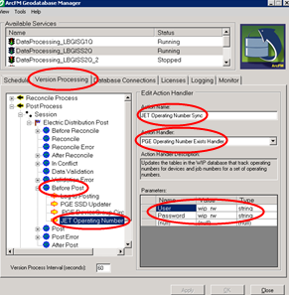

## Run Scripts to Create Application Data

1. Populate_EDER_Data.sql
   1. Creates an entry in the table SDE.TELEVENT_VALIDATION_SEVERITYMAP which defines the QA/QC error level to be a warning.
2. JET_MASTER_Table.sql
   1. Populates the table WEBR.JET_EQUIPIDTYPE.
   2. Populates the table WEBR.JET_EQUIPTYPERULES.
   3. Populates the table WEBR.JET_EQUIPTYPESELECTION.

## Adjust the CGC12 Domain

1. Launch ArcCatalog
2. Connect to the appropriate database as the EDGIS user (the domain owner).
3. Right-click on the geodatabase connection and select the Properties menu option from the context menu.
4. Select the Domains tab.
5. Scroll down the domains list and select the CGC Range Domain.
6. Change the minimum value to 0.
7. Press Apply to save the change.

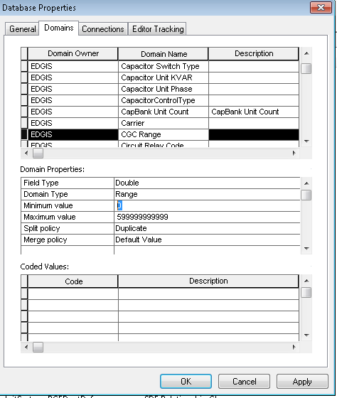

## 25576: Hide AVAILABLE field on duct and ductdefinition

1. Right-click on the Duct feature class in the UFM dataset and select ArcFM Properties Manager
2. Select the Field Info tab
3. Select the AVAILABLE field
4. Modify the Visible field property to be No
5. Click OK

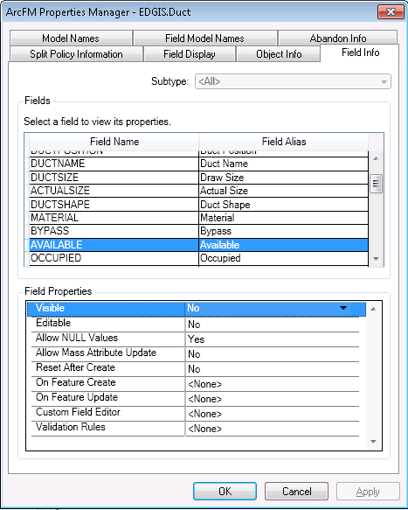

1. Right-click on the DuctDefinition table in the root dataset and select ArcFM Properties Manager
2. Select the Field Info tab
3. Select the AVAILABLE field
4. Modify the Visible field property to be No
5. Click OK
   1. **Update Data Model Version Table**

**Database Configuration:**

1. Open SQL Plus.
2. Log in using the same server and user as was used in section 2.1.  
     
   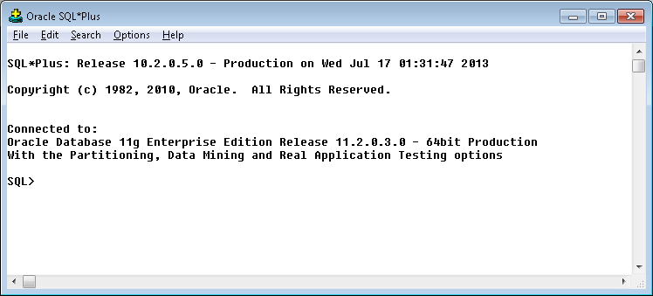
3. Run the SQL below:

update pgedatamodelversion set currentidc='N' where currentidc='Y';

insert into pgedatamodelversion (OBJECTID, CURRENTIDC, DATEAPPLIED, APPLIEDBYPERSONNAME, MODELVERSION) values (**SDE.VERSION_USER_DDL.NEXT_ROW_ID('EDGIS',(select registration_id from sde.table_registry where table_name='PGEDATAMODELVERSION'))**,'Y',sysdate,'***<your_name>***','**9.8** GOLD');

commit;

1. **WIP 3.0**
   1. **Apply TFS 25662 Create JET tables in WIP**

$/EDAMGIS/Source_Development_10_2_1/Documentation/Data Model/Release Documentation/EDER/9.8/

1) Copy the **Create_JET_Tables_and_Fields.py** file locally from the supporting documents folder referenced above.

2) Right click on the .py file and open it in IDLE editor.

3) Edit the “**Data_Connection**” in the file to use the correct password-saved SDE file. This SDE file should connect to the database as WEBR.

Release all existing locks in the SDE to ensure exclusive connection.

4) Execute the script.

* 1. **Apply TFS 25487 Grant Business Objects permissions to WIP**

[Change Request 25487:](http://edappgistfsprd1:8080/tfs/ElectricDistCollection/EDAMGIS/_workitems/edit/25487)Grant Business Objects permissions to WIP

Instructions

-------------

1) Get the following script from TFS:

$/EDAMGIS/Source_Development_10_2_1/Documentation/Data Model/Release Documentation/EDER/9.8/wip_bo_perms.py

2) Open in a text editor

3) Modify the sde path dataConnection to point to a password-saved SDE connection file with the target WIP database

4) Save

5) Execute the python script

6) Ensure No errors occurred

Validation Steps

------------------

1) In SQLPLUS, connect as edgisbo and ensure you can describe WEBR.jet_jobs table

* 1. **Update Data Model Version Table**

**Database Configuration:**

1. Open SQL Plus.
2. Log in using the same server and user as was used in section 2.1.  
     
   
3. Run the SQL below:

update pgedatamodelversion set currentidc='N' where currentidc='Y';

insert into pgedatamodelversion (OBJECTID, CURRENTIDC, DATEAPPLIED, APPLIEDBYPERSONNAME, MODELVERSION) values (**SDE.VERSION_USER_DDL.NEXT_ROW_ID('WEBR',(select registration_id from sde.table_registry where table_name='PGEDATAMODELVERSION'))**,'Y',sysdate,'***<your_name>***','**3.0** GOLD');

commit;

1. **Known Issues**

<Please List any other issues encountered here while following the document>